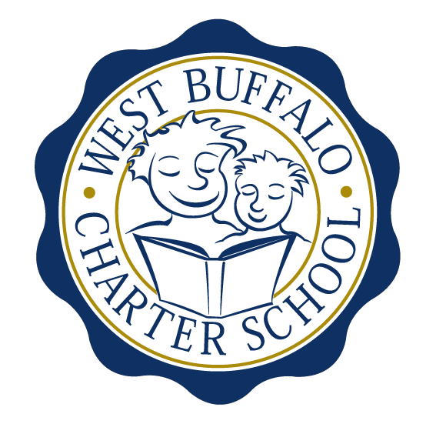
West Buffalo Charter School

Board of Trustees Meeting
November 23rd, 2015
2:30 PM
D’Youville College
Bauer Family Academic Center, Room 105

Minutes

Board Members:
Present: Arup Sen, James Deuschle, Michelle Stevens, Joanne Haefner, Richard Baer, Lee Pearce, Cynthia Stark, James Sampson, Lucy Candelario

Excused: Joseph Cozzo
Quorum Present: Yes
Also Present: Andrea Todoro, Liz Sterns

Call to Order
Dr. Sen called the Meeting to order at 2:32 PM. Quorum present.

Proof of Public Notice of Meeting
Media and public announcement was sent on Monday, November 16th, 2015 to print, radio, and TV outlets announcing this open meeting. A posting was also sent to Erie County Hall, Buffalo City Hall and Buffalo City Court. In addition, it was publicly displayed at 50 East North Street and posted on the WBCS website. The Board of Trustees was duly notified of this meeting well within the timeline of our bylaws.

Review of the October 26th, 2015 Meeting Minutes
Minutes of the October 26th, 2015 Board of Trustees meeting were presented for approval.

Upon motion duly made by Mrs. Stevens and seconded by Mr. Sampson, the minutes of the October 26th, 2015 board meeting were approved as presented. All in favor. Non-opposed.

- Mrs. Todoro and Mrs. Sterns updated the Board on the WBCS expansion plan and application.

Financial Report
Mrs. Sterns presented the financial report for the period ending October 31st, 2015 (a copy which is attached hereto and made a part hereof).
- WBCS will again be taking part in the Boxes of Love program. The school will be accepting donated new toys and/or cash donations that will be used by the Buffalo Dream Center to provide food and toys for the families of WBCS students.

School Leader Report

Mrs. Todoro presented the School Leader report (a copy which is attached hereto and made a part hereof).

- Mrs. Todoro presented data regarding the practice New York State ELA and Math assessment scores for both the 3rd and 4th grade students.
- Mrs. Todoro presented the 2015-2016 fall and winter AimsWeb data.

Adjournment

There being no further business to discuss, a motion to dismiss was made by Mr. Baer and seconded by Mr. Sampson. The meeting was adjourned 3:42 PM.

Respectfully submitted,
Leslie Bunis Ohl

The next board meeting is scheduled for Monday, December 14th, 2015 at 2:30 PM at D’Youville College (Bauer Family Academic Center-BFAC, Room 105).

